In this lesson we will learn how to create a cool little Android game within a very short time
So this is an overview how our will look
We click on play button and the game will start running and then the player starts running and here we have obstacles we will avoid them by jumping over them.whenever we get collided with the obstacle the game get restarted so we need to jump in order to do avoid the obstacles and that's how we can score high
So Lets get started.
Make sure your editor is latest or if it is lts then it should be latest
Note:-
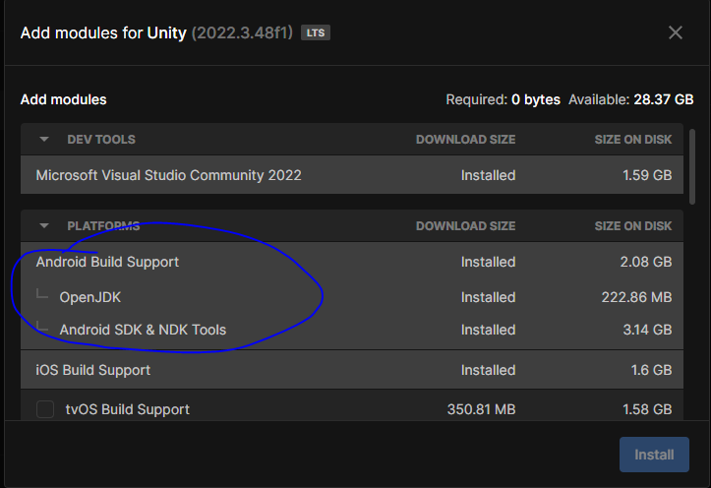
The marked above things is required in Editor for our game
Now we create our new game
So we reach the Project creation window

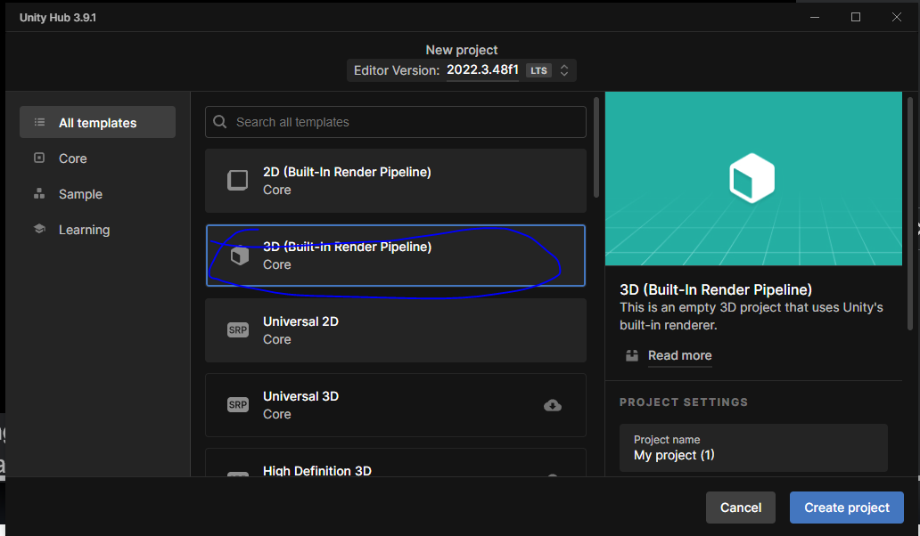
and then here we choose 3D (Built in Render Pipeline) as marked above
and then name of the project as Cube Runner
and then we click on the Create Project.
Our projet will be created now.
So now our project will be creted and opened
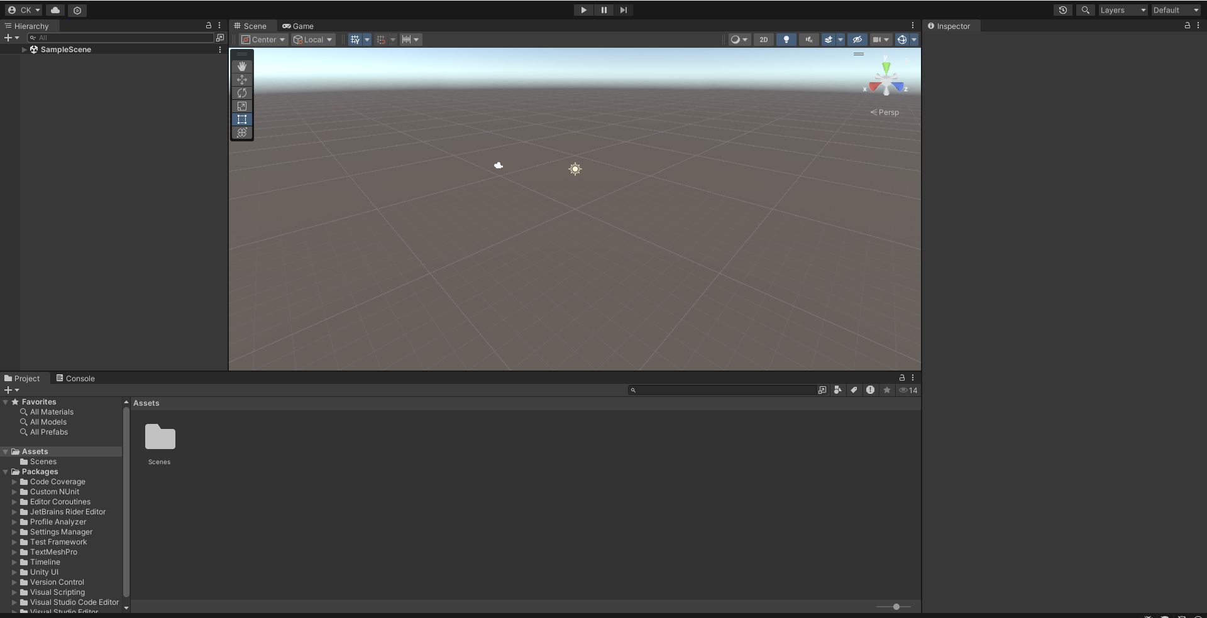
and now you can see it is in default layout
Now we will convert into 2 by 3 layout
So this is the layout that teacher prefer while building our game
In build setting switch it to Android
_________________________________________________________________
Note:-
The option you see in platform in Unity Build settings is actaually are the component we installed while installing editor.
_________________________________________________________________
Now change our by default scene to Game Scene.
Now in our Game Panel
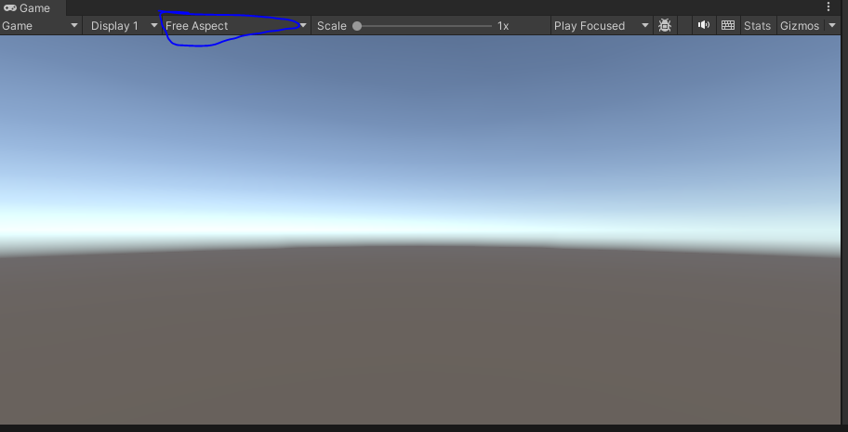
instead of free aspect choose 16:9 portrait aspect ratio
because these are going to be suitable for our Mobile Devices

In Unity, the Clear Flags property of the main camera determines how the camera clears the screen before rendering a new frame. It controls what is displayed in the camera's view when it begins rendering.

So in Heirarchy panel select the Main Camera and then go to its inspector panel and there
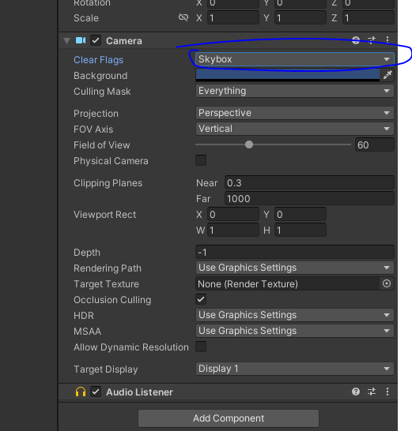
go to Clear flags and then choose Solid color instead of Skybox.
Now our Game Panel will be like this
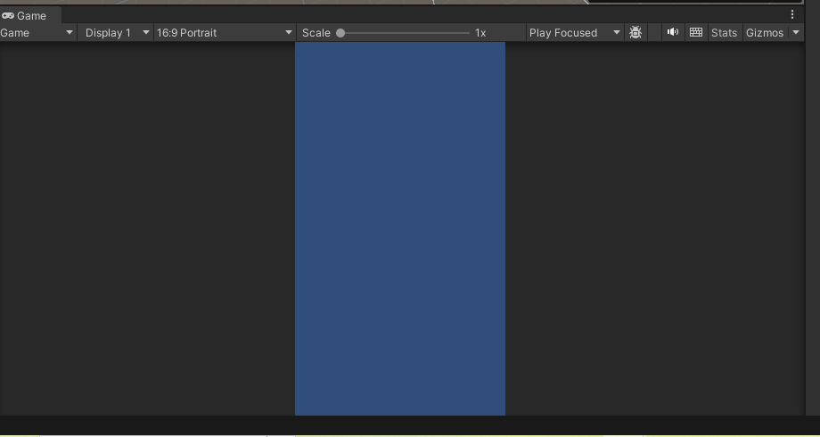
_________________________________________
Note:-
the background property will not work in case of skybox but only in solid color i think so.
_________________________________________
Now we are going to add two extra folders inside our assets folder
that is scripts and materials folder
These material folder will contain the material used in this game.
Now we will add a 3D object that is cube by clicking on the marked below
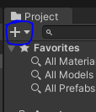
and then a submenu will be opened and then choose 3D objects and then a submenu will be opened and then in that submenu choose Cube
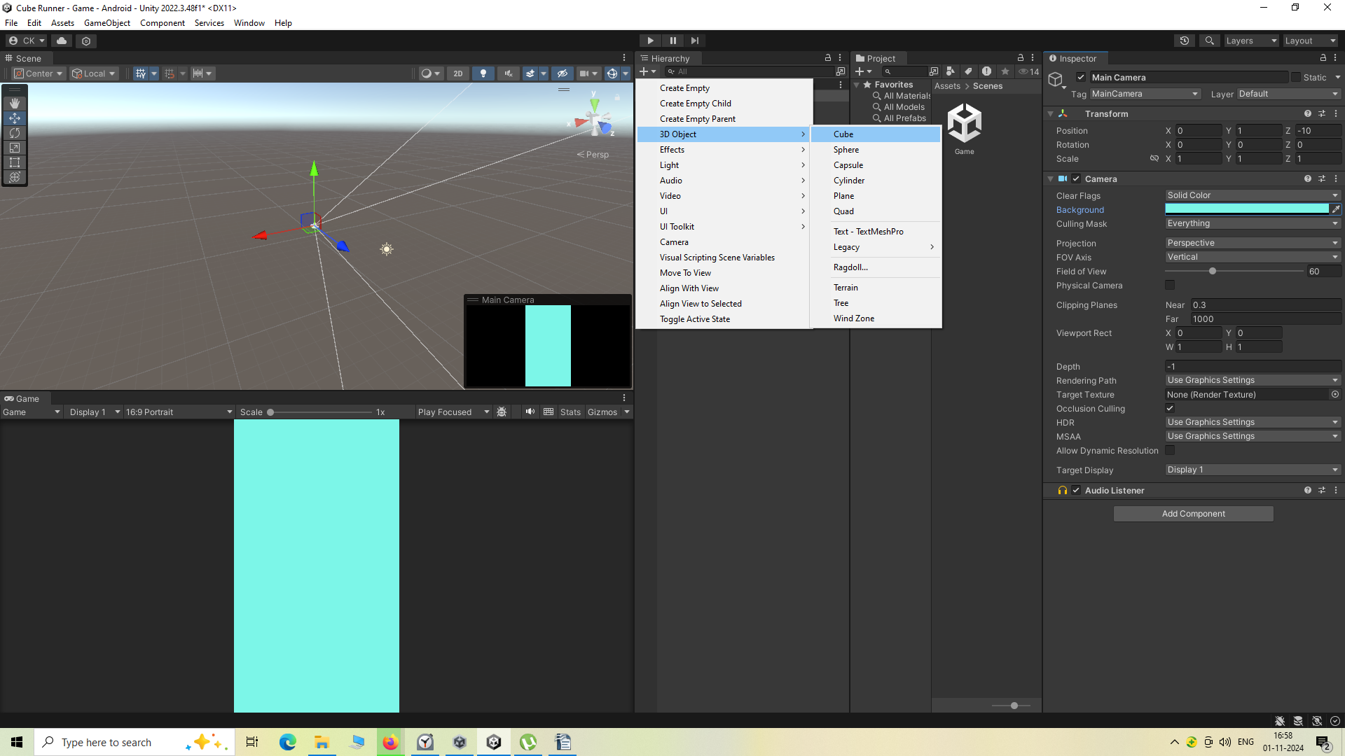
Now you will see the cube at the center of the Screen in Scene Tab as marked below
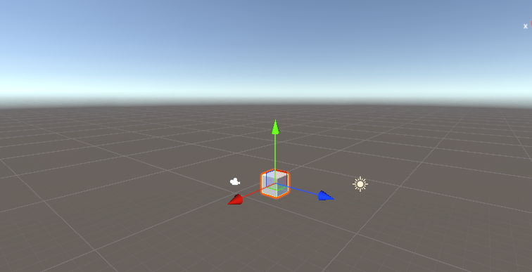

The blue colored arrow is called z axis.
And red colored is x axis
and green colored arrow is y axis
To rotate your view means view the scene tab from different angle by holding alt button and holding
left click
you can also do so by holding right click
But I think by Alt+left click you move your view around a point (who knows)
When i move by right click then the camera view around its own axis.
Make sure to take a view where the z axis is in front(pointing away) like below.
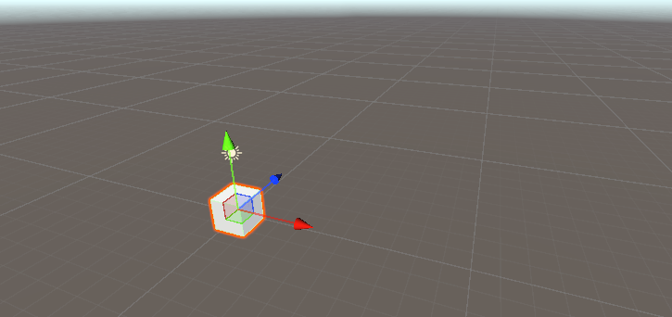
So now we will scale of z axis upto 200 so that we don't need to change it later
Now we will rename the cube to ground.
Now inside the Materials folder we will create a new Material
Way 1
by right clicking on the blank area of subpanel of Project in side the material and then in submenu opened click on create and then in new submenu click on Material
Or
Way 2
click on + symbol of Project panel and then in submenu follow the steps as shown in way after the right click in the blank area of Project subpanel
Note:-
Here we don't have a sprite folder because in 3D we deal with meshes with not some image.
We will name our new Material as Mat 1 marked below.
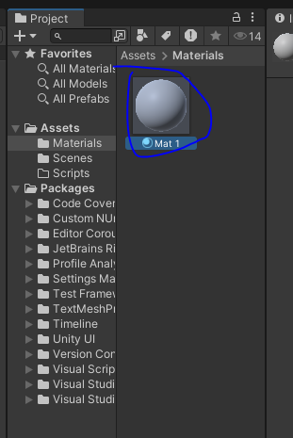
To copy and immediately paste something in the same area press ctrl+D
so we will duplicate our Material new formed Mat 1 material
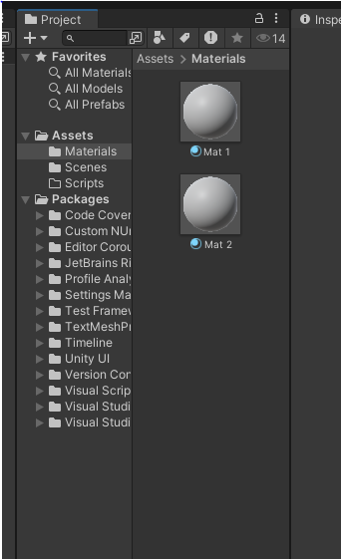
The duplicate material will be Mat 2
____________________________________________
Note:-
I think to avoid adding duplicate term in the name of duplicated item if there is a number mentioned inside the name of original then duplicate element will have a number incremented to the largest number present in the dupliacated items i think so.
____________________________________________
Now we again duplicate Mat 1 and duplicate it till we have four material which we can use it later
as shown below
Select the Mat 1 and then go to inspector panel and then go to Albedo field and then click on the bar beside it then a color bar will be opened choose the coloer for the material here.
We will color it to green thats what we are we going to give to our ground like below
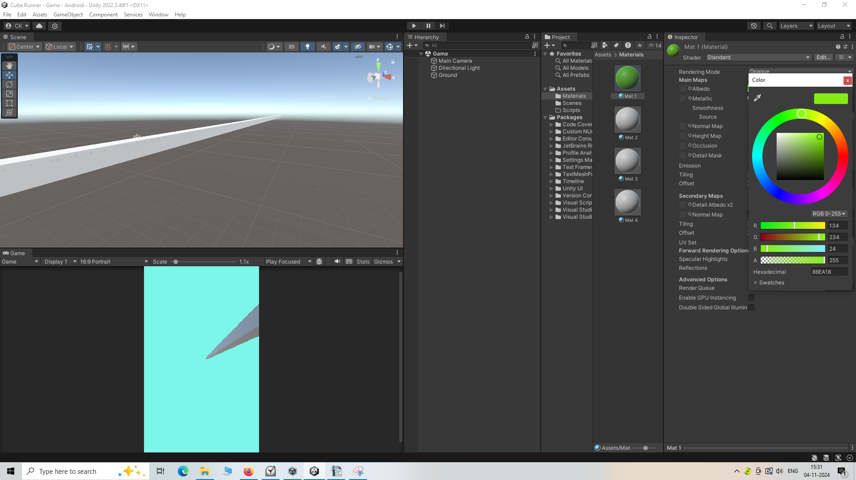
Now we drag and drop the material Mat 1 on the ground IOA present in the Scene Panel or in oue Heirarchy Panel
The ground will look like this now
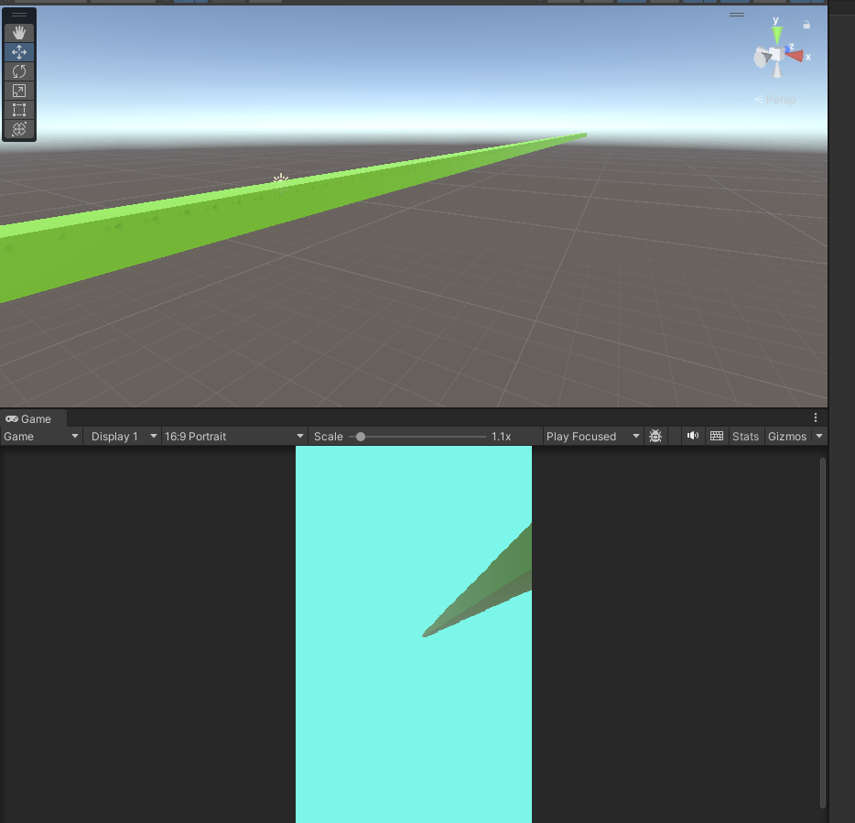
Now if your bring change in the color in the attached material then the changes will be seen in the IOA present on the screen to which the material was attached.
Now we will create a tag named as "Ground" and attach it to the ground IOA
Now we are going to add another cube in the Heirarachy panel.
Now we will name this cube as Player.
Now increase the y coordinate by 1.so nowv our player will be above the ground IOA
If not happening then first reset the Player IOA and then ground It will now look as the same Teacher Game Panel as shown below
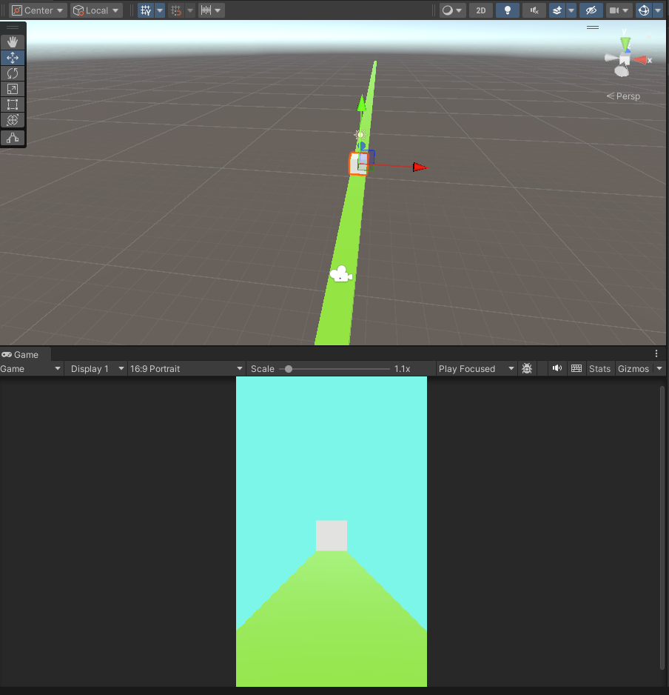
Now choose Mat 2 and then set its color to something red light and then we then attach it to Player IOA
So now our Player and ground is ready
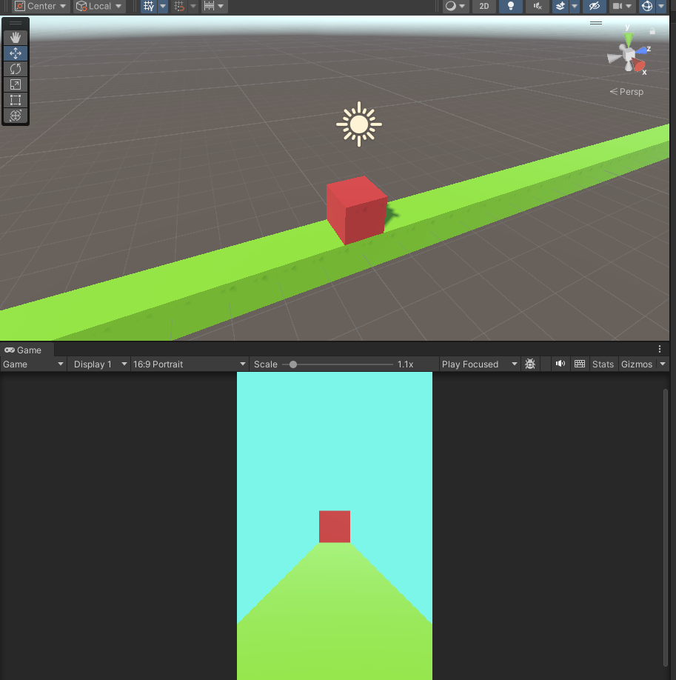
Now we need to set camera so that it looks cool.
Add Tag Player(maybe inbuilt) to the Player IOA.
Now we are going to select our Camera and change its position a little bit.
______________________________________
Note:-
To Zoom in or Zoom out we can scroll up or scroll down.
______________________________________
Now will move our camera along x direction by dragging the x axis of camera (red axis)
Make the x axis 9.98, rotate the camera -45 degree on y axis and move the y position above so that it looks good
So this way it's going to be at the view where we actually want it to be.
Also we can increase or decrease our field of view(maybe here we choose how much we want to see our view from static position).
If we increase it basicaly zoom out and if we decrease it then zoom in happens (will do it later)
So now we have our player and we have our ground so lets create an obstacle
For this we will create a cube and will name it obstacle
and increase its x scale by 5
make y scale 2
and set position y as 0.5.
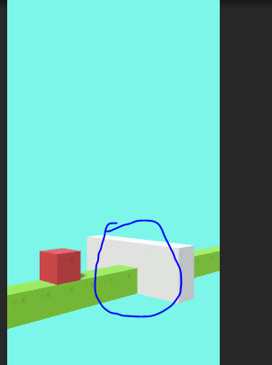
The marked above is the obstacles . The obstacles will comw slowly to our players and then we have to dodge them by jumping over it
Now we need to set the color of our obstacle so for that we will attach Mat 3 to it and then set the color of Mat 3 suitable for our obstacles we set it to color as mentioned below
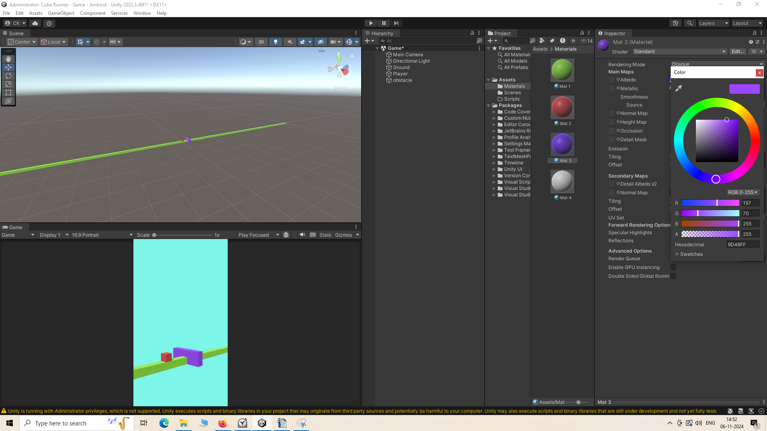
Create a new tag and add it to our Obstacle
Lets create a script and program our player so that i can jump our player by tapping on the screen
_____________________________________
Note:-
When field of view is increased(zoom out) and then we move the camera closer to the object then those object will look elongated (i don't know why)
_____________________________________
so we create a script inside the scripts folder and name it as PlayerController and then attach it to our Player IOA.
Now we will add Rigidbody component
fot it when this time when you click on the add component and this time in submenu chosse Physics >Rigidbody
So this rigidbody is what makes this one interact with physics
If you want to add the builtin functionality of physics we need to add a Rigidbody component to it
Now inside the inpector panel's Rigidbody we need gravity so we will keep it checked
but we don't need Angular drag so we will set it to 0
and we don't want to rotate player in x ,y or x zaxis so we will check them to freze it
We also don't need to move our player along x or z axis we simply want to move our player above so we will keep the y unchecked but keep the x and z checked.
All the confiuration is shown below
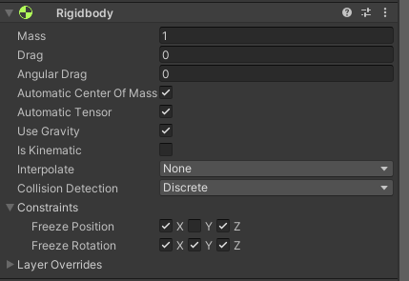
Note:-
In a 3d object box collidor component is added by default
we will now open Player controller script
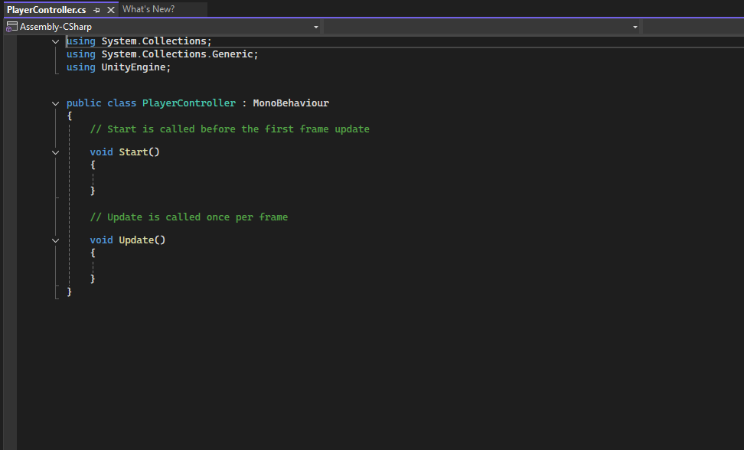
we will need a variables that will decide how our game works
we will declare a variable of type Rigidbody and then we add a float variable named jumpForce which will decide how much the player can jump
we will declare variable named canJump which will decide whetherour player can jump or not
Noe we are going ot write awake function which gets called even before start method when we start the game
inside this awake method we get the reference of the rigidbody attached to our gameobject to whom our script is attached to and then store it inside the Rigidbody variable
So now whatever we want to do with this RigidBody we want to add Gravity , we want to add Force ,velocity ,we can simply by using this rb variable.
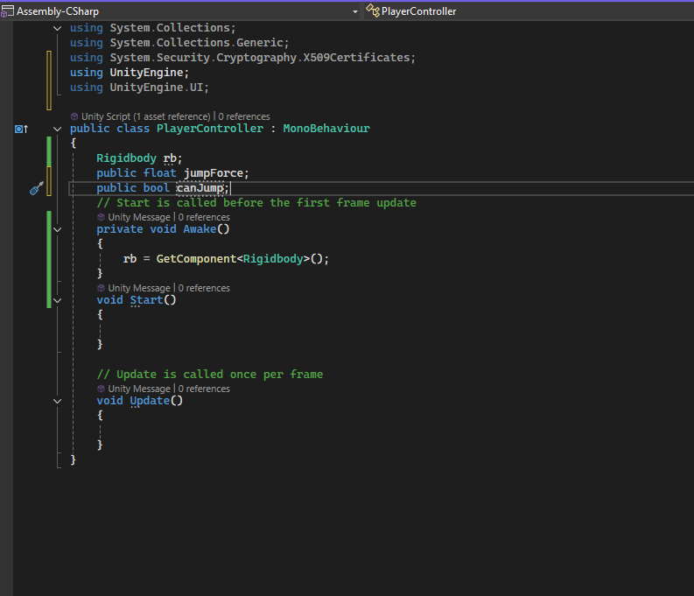
Inside the update function we are going to check if we are tapping or clicking on the screen
we do it by using the method Input.getMouseButtonDown(0) Here 0 specify left click this one works for touch as well so you don't need to worry whether you are working on PC
if the touch happened then we will make the block jump upward along y axis by writte ing this code as shown below
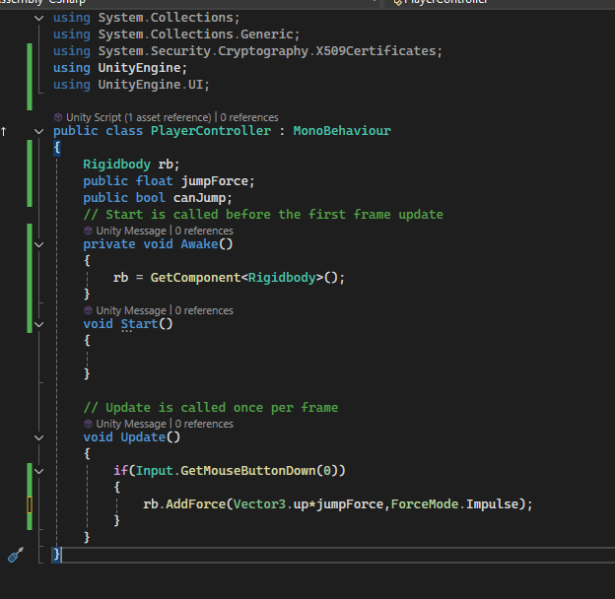
in Add force we add another argument ForceMode.Impulse it will make the force very huge if it is not added then you need to give high value for high jump like 300 but with it if you enter less value like 10 or 20 then still you will get high jump
to add force in upward direction we will use the Vector3.up to move the player up as shown above
Now we go back to oiur untiy editor and then in script panel of the Player IOA and then set the value of AddForce as marked below
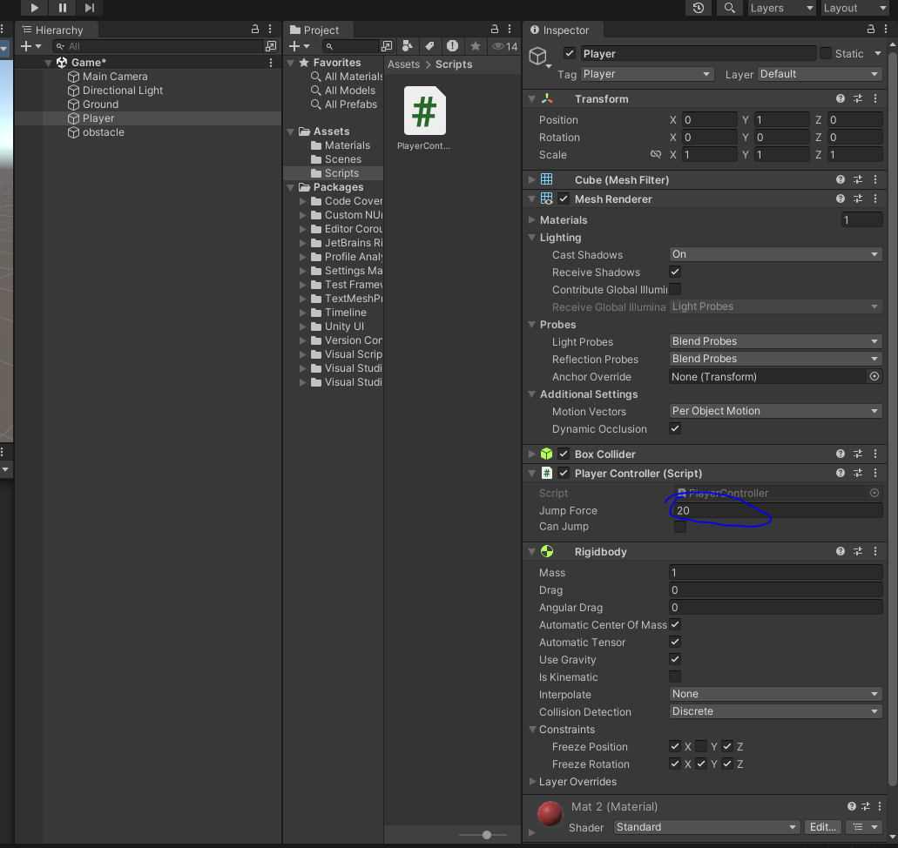
Now when we tap on the screen the player wil jump as shown below
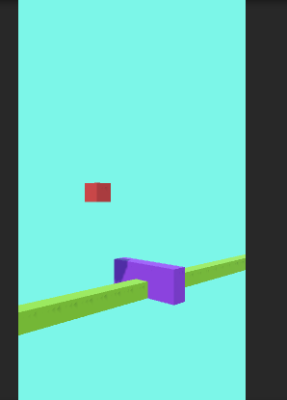
but you will observed when it moves down then it seems floating or very slow and not coming to ground very quickly This is because we have a gravity defined by the Unity as you can see from the marked below.
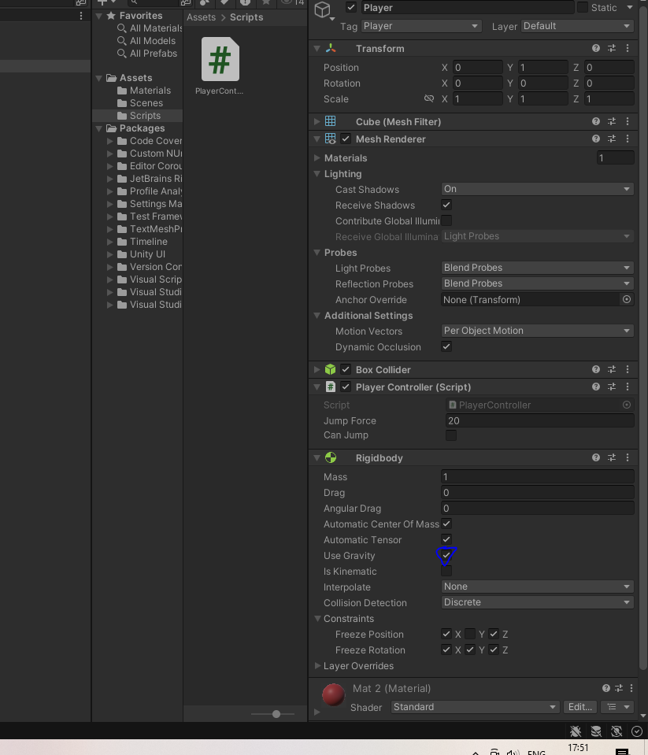
We can go ahead and increase the amount of gravity so that the player falls down faster. You need to go to edit menu and then a submenu will be opened and then go to project settings a window will be opened like below
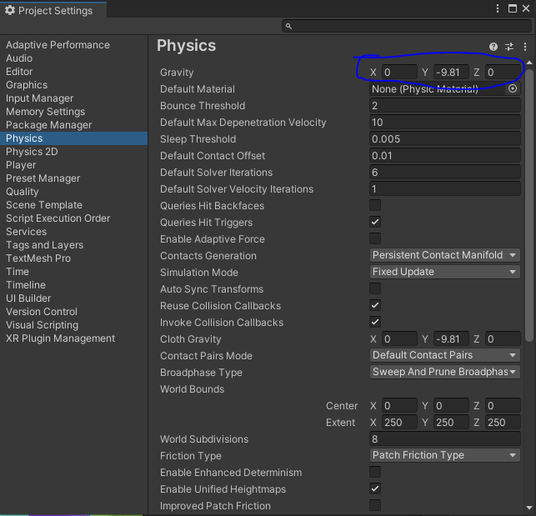
Now go to Physics sidemenu and then go to marked area of gravity section.
you can see in Y field gravity is set to -9.81 which is equal to earths gravity but to make the player fall faster on the ground increase
____________________________
Note:-
I have come to the conclusion that by this way you can set up the direction where gravity works
____________________________
lets suppose we increase the gravity upto -50
Now you can see that our player is jumping and reaching the ground very fast and the player is not jumping very high
But now there is another problem that if we repeatedly press the screen or click on the screen then the player repeatedly jump even if it is in the air and it jump higher.
We only want that our player will only jump only when it is on the ground.
So for it we will reach the player script and use the method onCollisionEnter which will be called whenver the IOA to which the script is attached to collide with other IOA
So inside it we will take the help of tag to detect when the player collide with other tagged IOA and take action according to it.
We are going to use another method named as onCollisionExit which is called whenever you move away from the the object your IOA collided with(after collsion your IOA may get attached to other IOA to which it get collided with or move away from it).
To do this make sure that your Ground tag is attached to your Ground IOA.
Here's below shows how your code will look
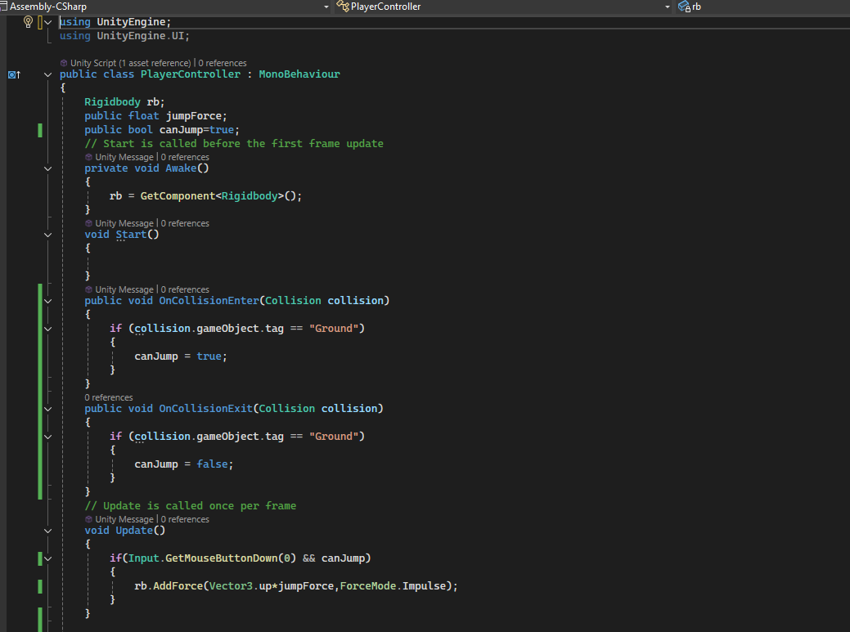
Also make sure that your Player IOA has the RigidBody and BoxCollidor component attached to it. Otherwise these things will work not correctly.
So now our player is working we need to make our obstacle move towards the player.
______________
Note:-
I think that physical dynamics of 2D and 3D are different In 2D when you drag one object and make it interact to another object.(work only when both the colliding object have Rigidbody component attached to it)
______________
there is a property called istrigger which when unchecked then that object will interact with other object but also detect the collision but when it is checked then object only detect collision but not interact with it but go through it
because we have two collidors one is ground and another is obstacles
So we are going to make our ground collide and obstacle trigger
The above is true only when movement of object is made of the code or engine not of manual drag and drop.
Now we are going to make a script called Obstacles and attach it as a component to the obstacles IOA.
Now inside our obstacles script we cannot use RigidBody as Obstacle IOA does not have RigidBody attached to it.
So we will use method transform.Translate
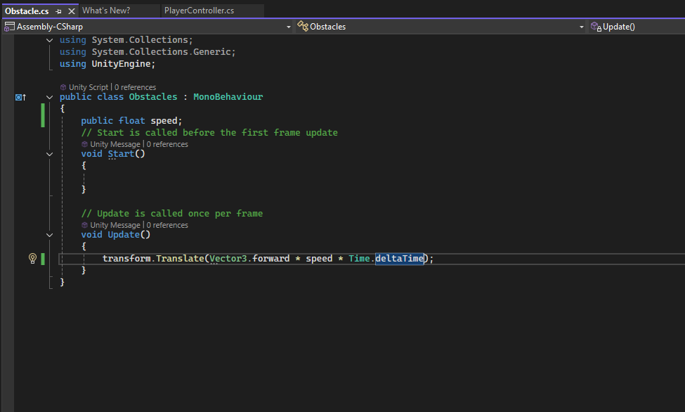
In above code we have used Vector3.forward which move our player in z direction
To make our movement of obstacle frame independent we multiply the distance travelled (Vector3.forward * speed ) by the Time.deltaTime which will convert it to distance travelled per frame

The Problem: Without Time.deltaTime, the Speed Is Frame Rate Dependent
When you move an object by a fixed amount each frame, the distance the object moves is dependent on how many frames are rendered in a second.
- At higher frame rates (e.g., 120 FPS), the object moves further because more frames are rendered each second, and each frame updates the object's position.
- At lower frame rates (e.g., 30 FPS), the object moves less because fewer frames are rendered, and there are fewer updates to the position per second.

If the game is running at 60 FPS, Time.deltaTime will be around 0.01667, and the object will move 10 * 0.01667 = 0.16667 units per frame.
- If the game drops to 30 FPS, Time.deltaTime will be around 0.03333, and the object will move 10 * 0.03333 = 0.3333 units per frame.
So the deltaTime chsnge with device (maybe maximum fps of that device)
It make the movement very smooth and time independent we do it.
So with this code will slowly move towards the player make sure the speed is negative so that the obstacle will move towards the player otherwise it will move away from it.
We will use another method that is OnBecameInvisible() which is called when our IOA(to which our script is attached) move outside the camera view then it will be called
give the value to speed in obstacle as negative in inspector panel of obstacle a marked below
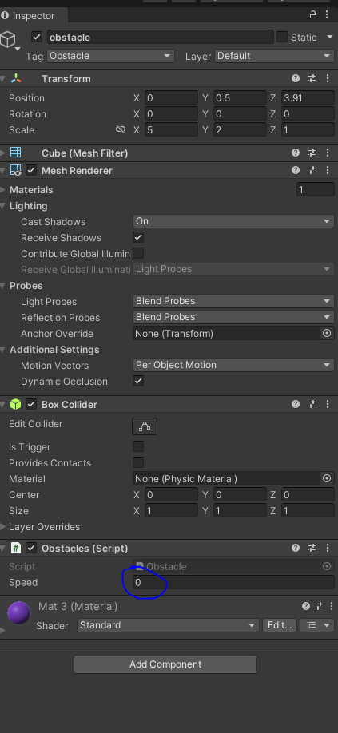
Now we are going to reuse this obstacle again and again
For that we need to make it a prefab.
So Prefab is an object which we use again and again with the same properties.
We already know how to make it (from previous lessons)
So what we want to do is when our block collide with the player then the scene should be reloaded because the game is over.
Now we are going to create a method in our player script called onTriggerEnter (It is due to the option istrigger checked) It will get activated when our IOA to whom our script is attached to get in contact with other IOA which have Box collidor component.
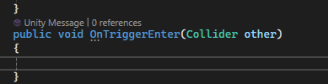
The other variable contains the reference of the IOA to whom our Player is collided . The variable contain all the properties of that object who has collided with our Player.
To load our scene we need to use LoadScene method which we get by import UnityEngine.Scenemanagement as we had seen in our previous lesson.
Now a lot of times this scene reloading does not work when our game is built. So go to build settings and then in its window.
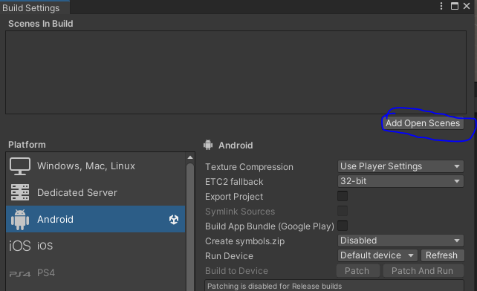
Click on Add Open Scenes button it will all the scenes opened in your Game in your build(maybe)
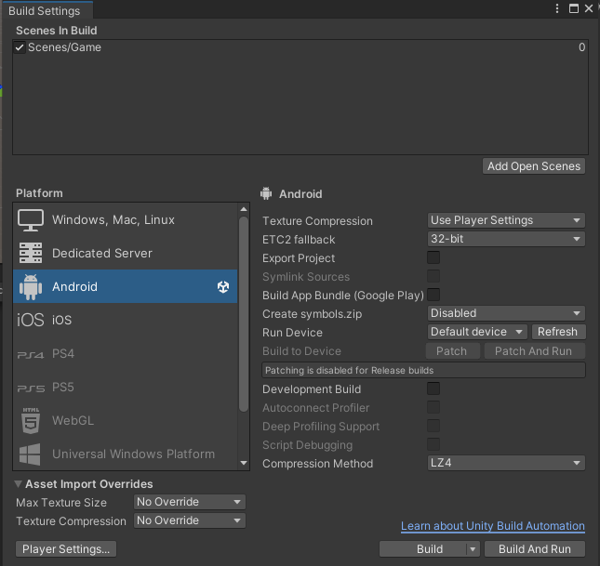
Now in above screen you can see that our scenes are added. And it has also an is associated with that is 0.
Now we need to find a way to spawn the obstacles so that it again and again and come towards the player.
Now for that we need to add a GameManager that is Empty object we will attach a script to it.
We name the script GameManager and now we open it
So now in our GameManager script we use variable for referencing our Prefab obstacles and also varianble for referncing to a spawnpoint from where the obstacle are originated this spawnpoint is actually an Empty object.
We will also declare a variable called score to store the score.
We will create a public method GameStart
This will take care of everything whenever the Game starts like it will start spawning and it will keep the score
To startspawing we mean generate the obstacle after some random interval so for that we will use coroutines
In Unity, the IEnumerator method is commonly used to define coroutines. Coroutines are special functions that allow you to perform operations over multiple frames, instead of executing all at once in a single frame. This is particularly useful for tasks like waiting for a specific amount of time, gradually changing values, or performing actions that span multiple frames.
Here's a breakdown of how IEnumerator is used in Unity C#:

1. Coroutine Basics
- IEnumerator is a return type that you use for defining coroutines.
- To run a coroutine, you use the StartCoroutine method, passing in the method that returns an IEnumerator.
- Coroutines allow you to pause execution at specific points (using yield), which gives control back to Unity until the next frame or until a condition is met.
We will make a coroutine in which we will run an infinite loop and make the routine stop for 2 second and then continue the method after 2 seconds frame and then generate obstacle.
Now in our script component in the Game manager inspector panel it is asking obstacle reference and SpawnPoint reference as shown below
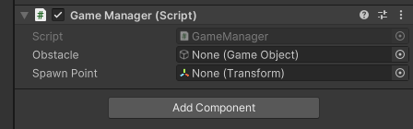
Now drag and drop the Obstacle IOA from Prefab to the obstacle field as shown above
disable the obstacle IOA present in the heiarchy panel.
We will make an empty object called spawn point . It is the point from which our obstacle will be generated we will align it in the same line as our obstacle IOA in the heirarchy which we disabled
now drag and drop it on the reference of Spawnpoint in the GameManager
___________________________
Note:-
I have discovered that when we applied the logic of destroying object when it go outside the camera View but the camera is actually whatever we see in our Scene Panel when that move outside our line of sight it will get destroyed . I think it will happen only while developing the Game not in our run time game I think in run time it will be destroyed after the the object go outside the game area.
And i also think in trigger one of the colliding IOA must be is trigger
___________________________
Now we need a score mechanism and a start button so that whenever we click it our game will start
So for that we need to make a canvas So for it go to + sign in Heirarchy panel and then in submenu go to UI and then to canvas now you will see a canvas is added to our Heirarchy panel as shown below
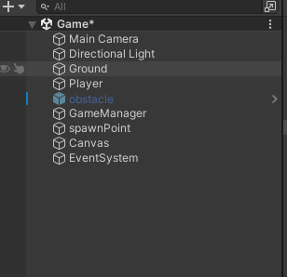
Inside it we have all our own UI elements likw Text Mesh Pro ,images etc.
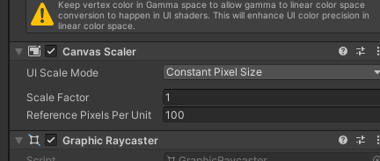
Now select the canvas and then go to inspector panel and then go to Canvas Scaler subpanel as shown below choose
scale with screen size instead of Constant Pixel Size in UI scale mode by this your UI elements will be scled according to the screen
___________________________________
Note:-
I don't have the knowledge i hope in future i will get the knowledge
___________________________________
For reference resolution we set it to to 1920 X 1080
Now set the match property to 0.5
No the properties will be as shown below
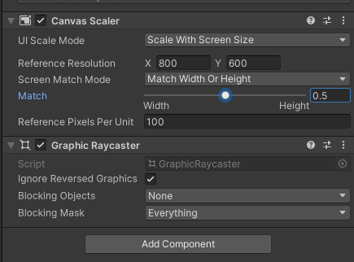
Now import a textmeshpro
It is very hard to make it a from the perspective view so we will see it from 2D mode so that we can easily edit thus UI
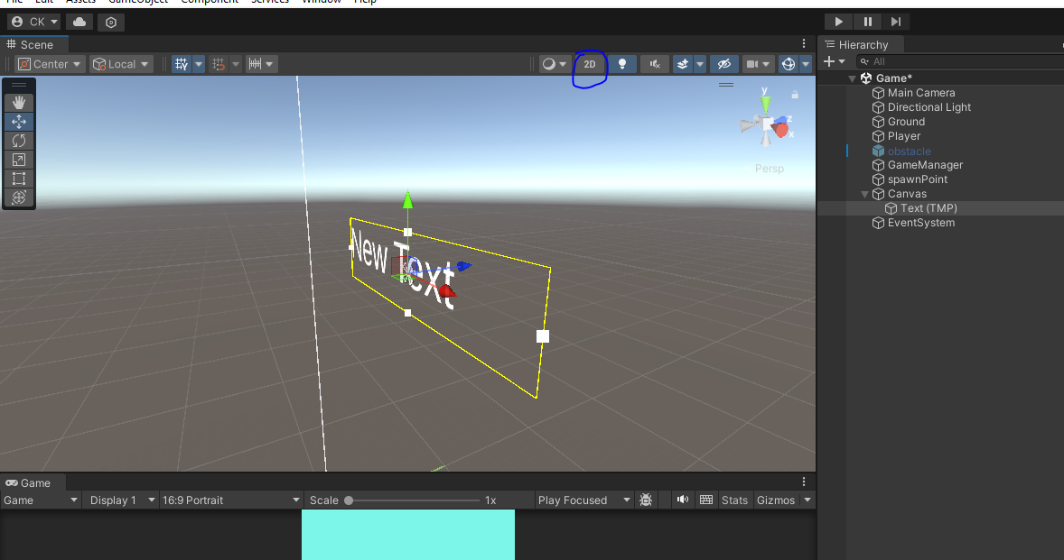
we double click on it to reach to it like any other object IOA in heirarchy panel
To go to 2D mode go to marked area in scene panel as shown below
I think in this mode you see your Scene from the front view as shown below
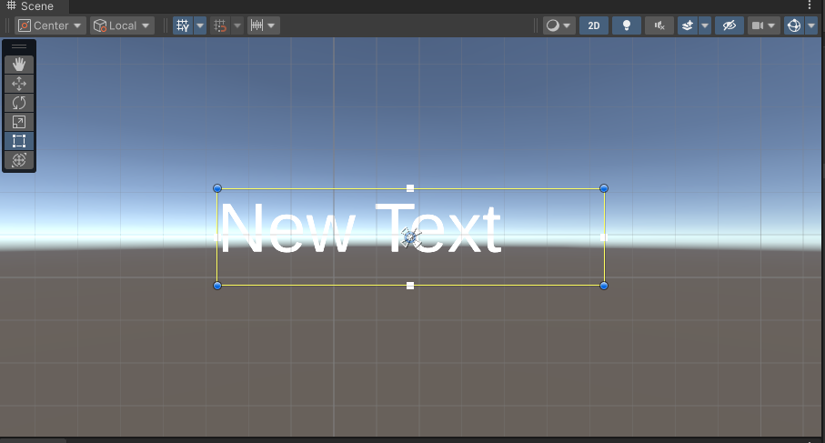
So by this you can easily edit your text
rename our text to scoretext
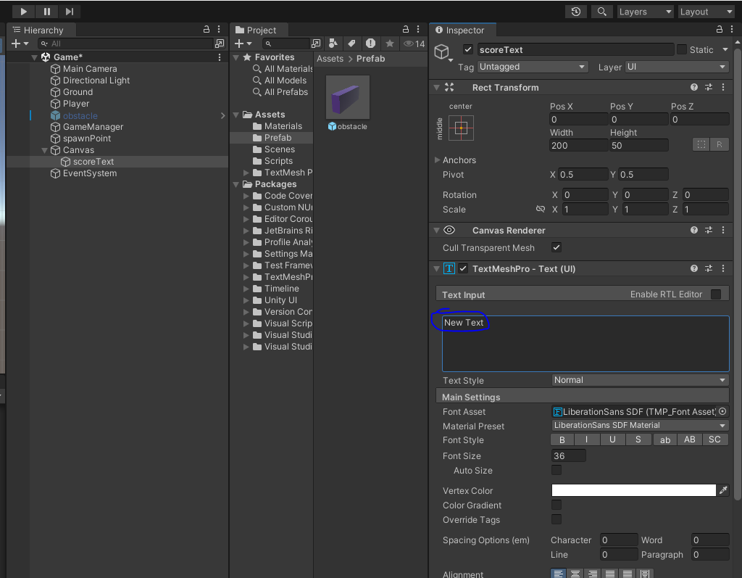
Now enter the text as 0 for your TextMeshPro in marked above so that your text will be 0 as this textmeshpro will be used for telling the score to the user playing the game.
By rectangle tool resize the textmeshproGUI and set the font size of it close to 300
Now align the text inside textmeshpro to the center.
_______________________________
Note:-
I think that when you scale by your scale tool then text is resized and when you resize it by rectangular tool it just resize its environment maybe for alignment purposes maybe.
_______________________________
Change the color of the text as we know from earlier lessons
Now we need to make a button by clicking which will start the game.
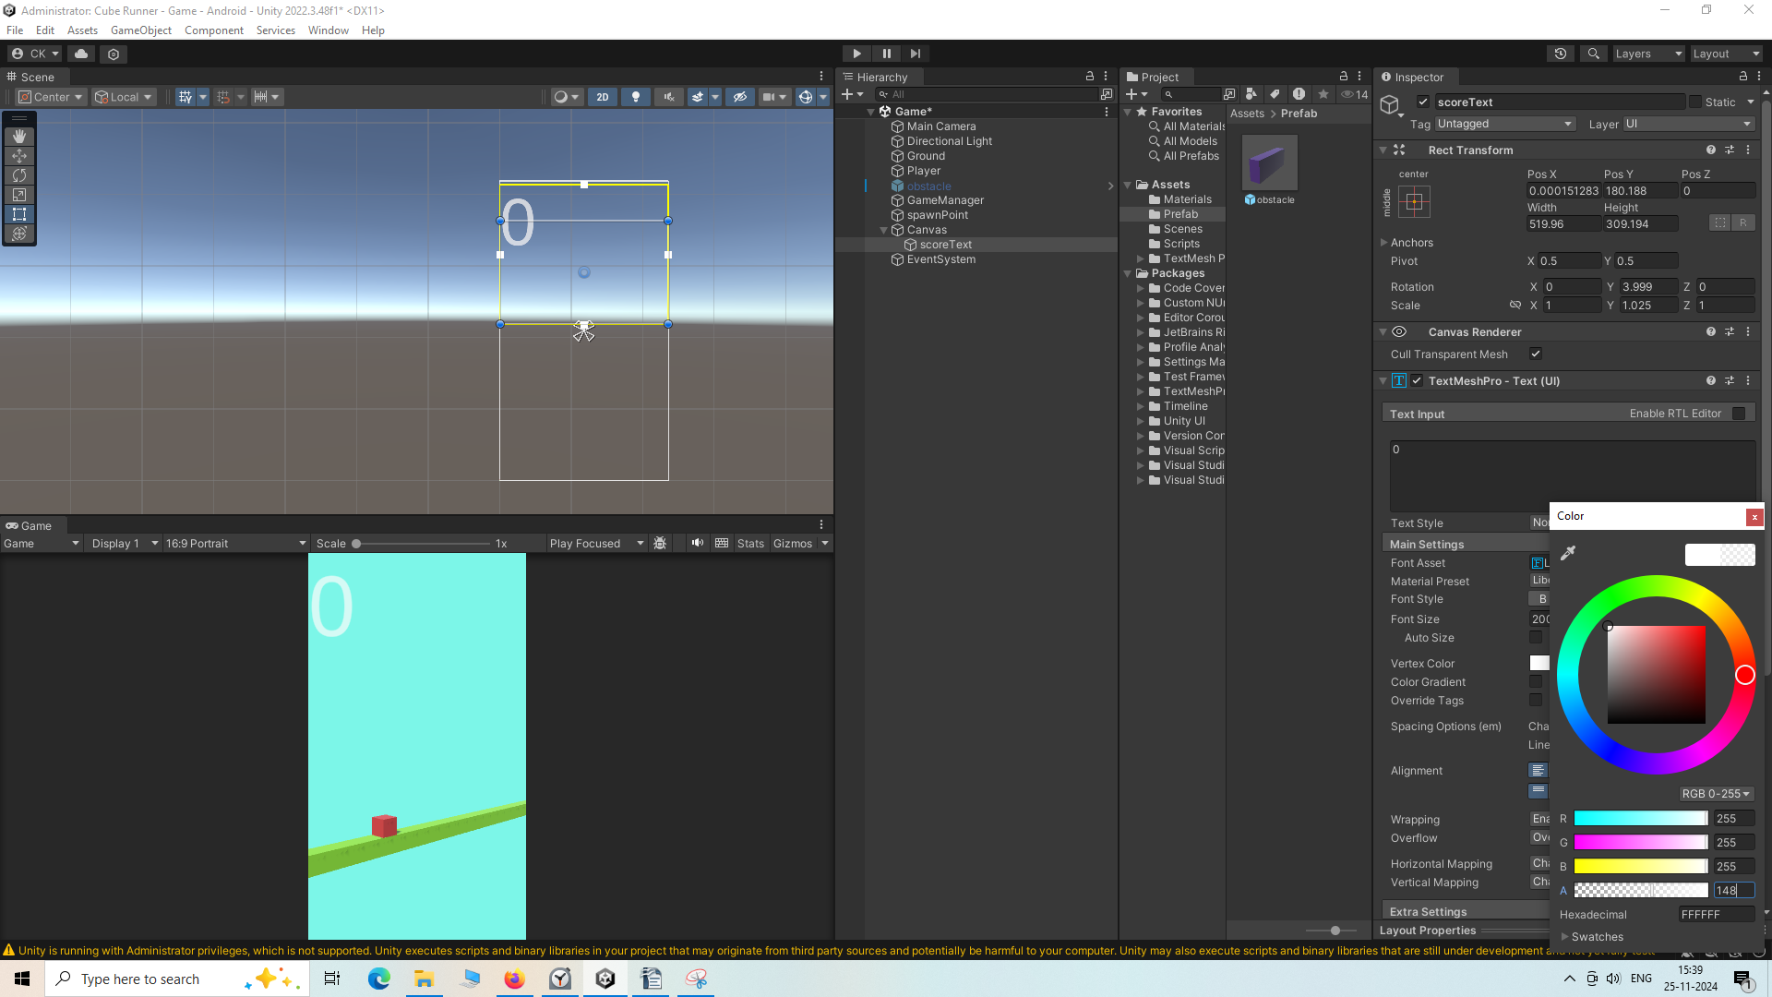
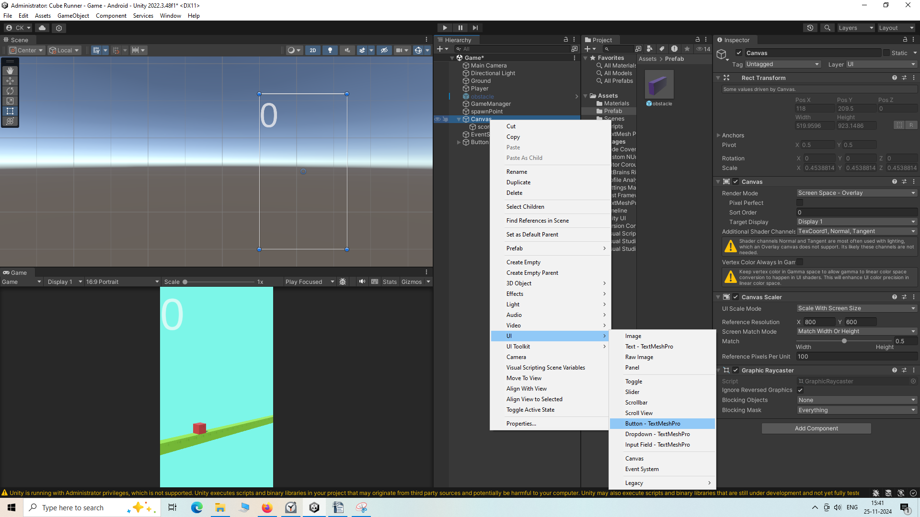
Now create button by going to
UI > Button-TextMeshPro
Now button-TextMeshpro is added to our Heirarchy and name it as PlayButton as shown below.
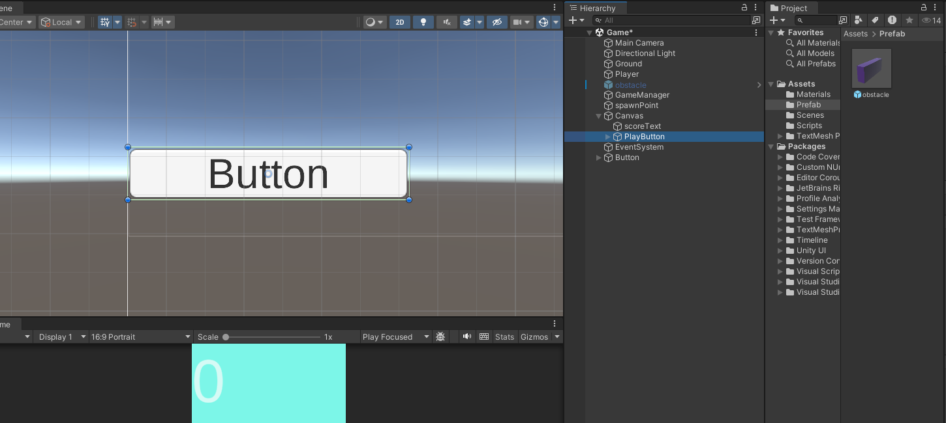
Now resize it we can use them as it is or slightly decorate it if we want
So we will remove the text Button Inside the button by deleting the textmeshpro inside the button
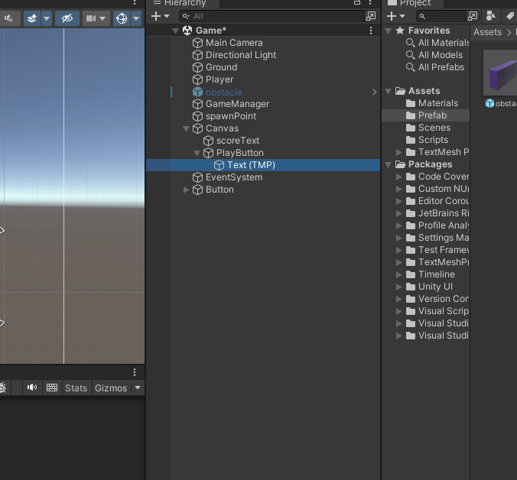
SO delete the text as highlighted above
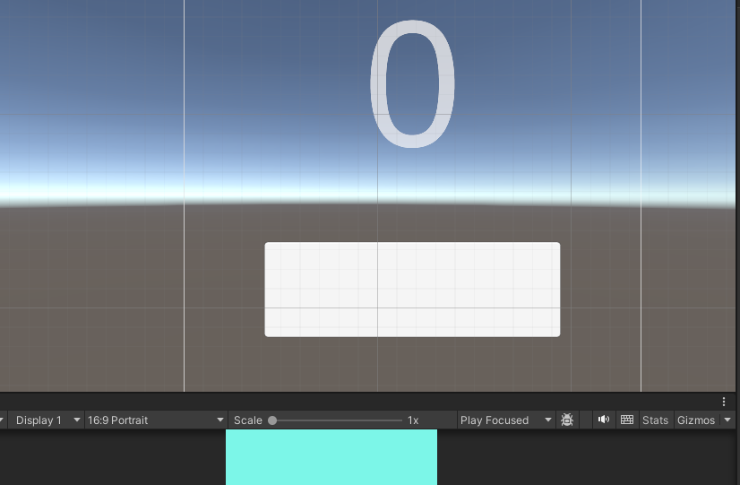
Now the button will look like above. Now instead of blank white button as shown above you can use image by using the marked below
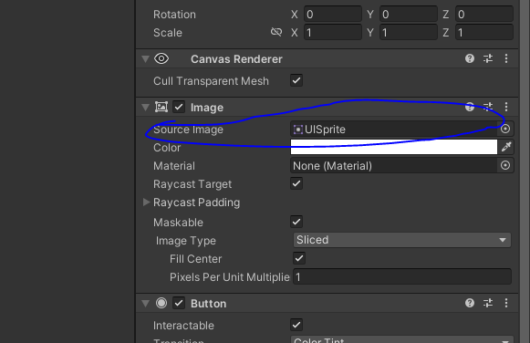
You can use download any button image you want or you can use photoshop to make that button.

